

**Garland Prospectus**

Little Beans Garland

59 Garland Road

Poole, Dorset BH15 2LD

[www.littlebeansdaycare.com](http://www.littlebeansdaycare.com)

**www.facebook.com/littlebeansgarland**

OFSTED registered – EY492436 - GOOD

Admin / Accounts: [thehub@littlebeansdaycare.com](mailto:thehub@littlebeansdaycare.com)

Manager: [manager@littlebeansdaycare.com](mailto:manager@littlebeansdaycare.com)

Tel: 01202 668439

**Introduction**

**Welcome to Little Beans**

We believe that each little bean should feel safe, secure, and confident; developing strong roots from which to grow. We seek to provide a stimulating “Enabling” environment that is central to the children’s learning and development. This allows them to flourish, develop and reach their full potential as unique individuals as well as reaching their early learning goals.

The roots that are planted during these early years are vital in developing the skills they need to take with them throughout their lives.

We also focus on building secure, positive, and strong relationships between children and their key person. This gives children the support and assurance they need to grow and shine in all areas of the Early Years Foundation Stage.

We pride ourselves on engaging with parents and families to create strong, positive partnerships - after all it is you who know your little beans best!

Our friendly and welcoming team will enthuse, engage, and motivate your little beans.

If you would like to come and visit us, then please give us a call. We would be happy to arrange a tour to show you the facilities we have available and to introduce you to our team.

We look forward to welcoming you to become a valuable part of Little Beans.

**From all the team at Little Beans!**

**Meet the Leadership Team**

**Sebrina - Director**

**“***I have many years of experience in the childcare sector and have five children of my own. I lead a great team and strive to deliver energy and enthusiasm in all that we do at Little Beans. In my view, children should feel safe, secure, and happy and be given all the support they need to fulfil their potential. This includes providing children with a broad range of knowledge and skills; quality and consistency of care where staff are supported through ongoing training and development; building positive relationships and treating each child as a unique individual.”*

**(Level 3 Early Years)**

**Tamsin – Director**

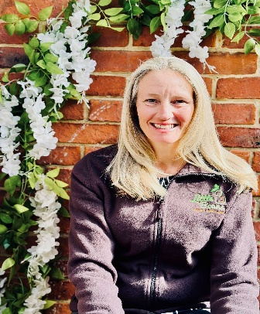“*I work in the background to support the team at Little Beans bringing my legal, management and consultancy skills into play. I have three children and so also bring a parent’s perspective to my role. We have a great team, and it is always enjoyable coming in to visit to witness in person the outcome of all the hard work and dedication poured into Little Beans every day by Sebrina and the team.”*

**(LLB Law : Hons)**

**Roshni – Manager, Designated Safeguarding Lead (DSL) & Little Beans Teacher**

*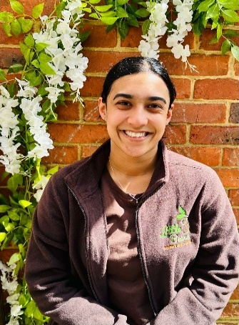“I am the manager at Little Beans Garland with over 10 years of childcare experience. I believe every child deserves the best start in life, and it's our duty to provide the highest standard of care. Before joining Little Beans, I advanced from Level 3 practitioner to deputy manager and Designated Safeguarding Lead, overseeing daily operations in the absence of the area manager. My diverse experience enables me to support our staff in nurturing and inspiring our Little Beans, ensuring they feel safe, secure, and reach their full potential.”*

**(Level 3 Early Years)**

*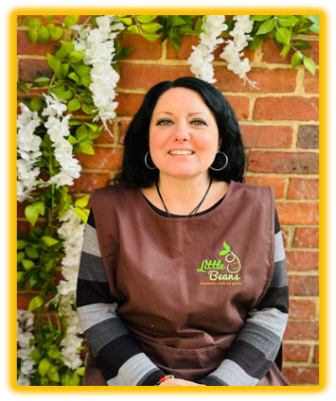***Sheryl – Interim Deputy Manager (trainee manager in process), DSL & Little Beans Teacher**

*“I attended Bournemouth University where I achieved my Level 5 Foundation Degree in Early Years. I have over 24 years of experience within childcare, and I am very excited to bring this knowledge and passion to Little Beans. ”*

**(Level 5 Foundation Degree in Early Years)**

**Ashleigh – 2nd Deputy Manager, DSL, Little Beans Teacher & Preschool Room Leader**

*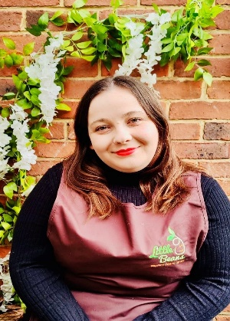“I have worked in childcare for the last 11 years. I started as an apprentice and throughout my journey I have worked my way up to a Level 5 qualification. I am very passionate about providing a safe, secure and stimulating environment in which your Little Beans can thrive and reach their full potential.”*

**(Level 5 Early Years)**

**Chiara – 2nd Deputy Manager, DSL, Little Beans Teacher & 2’s Room Leader**

* “I am passionate about early years education. With seven years of experience in the field, I have had the privilege of working with children and supporting their growth and development. I recently completed my undergraduate degree in education and my PGCE, where I focused on behaviour management and learning theories that align with children's needs. This academic journey has deepened my understanding of how children learn and thrive, and I’m excited to apply this knowledge in my work. I love working with children because I believe in the power of nurturing their curiosity and creativity. Watching them explore the world around them and helping them reach their potential brings me immense joy. I am dedicated to creating a positive and engaging learning environment where every child feels valued and supported.”*

**(Primary Initial Teacher Education)**

**Chanelle – 2nd Deputy Manager, DSL, Little Beans Teacher & Baby Room Leader**

*“I have been working at Little Beans for over 5 years now and I love everything about it. I started my apprenticeship here and I have worked my way up to baby room leader and 2nd deputy manager. I enjoy every element of my job, leading the baby room enables me to guide and nurture them in their first early years and it is such an honour to play a big part in that. I love watching them grow and flourish from the very start to when they go to school.”*

**(Level 3 Early Years)**

**Meet the Preschool Room Team**

**Ashleigh – 2nd Deputy Manager, Little Beans Teacher and Preschool Room Leader**

*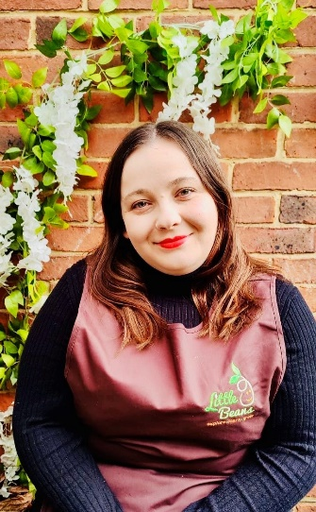 “I have worked in childcare for the last 11 years. I started as an apprentice and throughout my journey I have worked my way up to a Level 5 qualification. I am very passionate about providing a safe, secure and stimulating environment in which your Little Beans can thrive and reach their full potential****.”***

**(Level 5 Early Years)**

**Sophie – Little Beans Teacher, Preschool Room**

*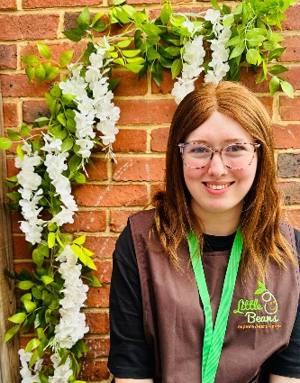“I will be working in the preschool room as a SEND practitioner to provide additional support for specific children. I have worked in childcare for almost 5 years and spent 3 of those years supporting children with additional needs. I have a passion for providing quality care and fun experiences for all children. I enjoy exploring sensory and messy play with the children as this allows the children to learn through play.”*

**(Level 3 Early Years)**

**Teigan – Little Beans Teacher, Preschool Room**

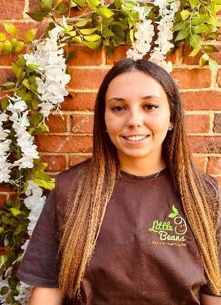

*“Ever since I left school, I knew I wanted to work with children. Growing up in a large family as one of seven, I was constantly surrounded by kids and gained plenty of babysitting experience! I have great patience with children and love helping them achieve their next milestones.”*

**(Level 2 - working towards Level 3 Early Years)**

**Layla – Little Beans Apprentice Teacher, Preschool Room**

*“Having grown up with younger siblings and cousins I have always known that I wanted a career with young children. I love being able to see them reach their own milestones and develop individually as well as them being themselves. Being able to watch them bring their own imagination to life with games and artwork is why I am so passionate about working in early years. I love working at Little Beans and am super excited for the career I have ahead of me.”*

**(Working towards level 3 Early Years)**

**Grace - Little Beans Apprentice Teacher, Preschool Room**

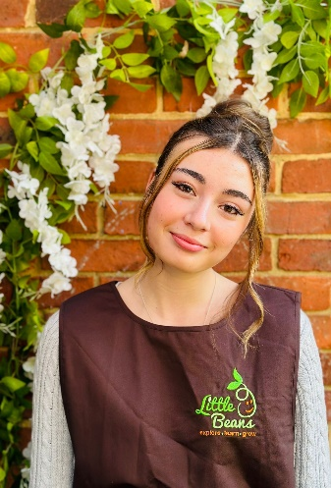

*“In the last couple of years I have found my love for working with children and I am delighted to extend this passion by starting my  journey as an apprentice. I am excited to work alongside your Little Beans supporting their growth and development during their time here with us.”*

**(Working towards level 2 Early Years)**

**Meet the 2 year old’s Room Team**

**Chiara – 2nd Deputy Manager, DSL, Little Beans Teacher & 2 year old’s Room Leader**

*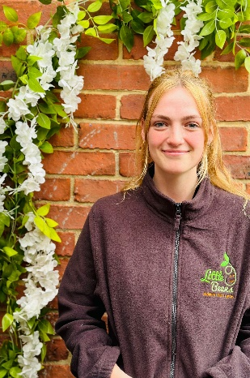“I am passionate about early years education. With seven years of experience in the field, I have had the privilege of working with children and supporting their growth and development. I recently completed my undergraduate degree in education and my PGCE, where I focused on behaviour management and learning theories that align with children's needs. This academic journey has deepened my understanding of how children learn and thrive, and I’m excited to apply this knowledge in my work. I love working with children because I believe in the power of nurturing their curiosity and creativity. Watching them explore the world around them and helping them reach their potential brings me immense joy. I am dedicated to creating a positive and engaging learning environment where every child feels valued and supported.”*

**(Primary Initial Teacher Education)**

**Rebecca – Little Beans Teacher, 2 year old’s Room**

*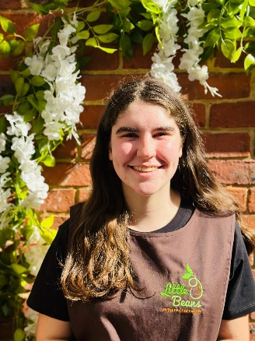“I am so happy about joining Little Beans and being able to put into practice the knowledge and skills I have gained over the last 2 years whilst I worked towards qualifying as a Level 3 Practitioner. Working with children is what I have always wanted to do since I was younger, achieving this makes me so excited for the journey ahead! I am passionate about giving children the best care in their early years as this will support their development and enable them to thrive through life.”*

**(Level 3 Early Years)**

**Kiera – Little Beans Teacher, 2 year old’s Room**

*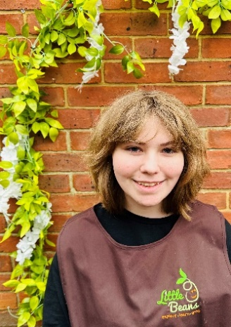“I have a passion for wanting to support children in learning new and important skills they need in the future and watching them grow to their full potential. I aim to help them show their creative side so they learn to use their imagination and become more independent when doing daily tasks, playing or creating their own games.”*

**(Level 2 Early Years)**

**Tamzin – Little Beans Apprentice Teacher, 2 year old’s Room**

*****“After looking after my younger cousins, I realised that working with children was the future ahead of me. Watching the children grow, seeing their personalities come to life and the children being unique in their own little ways brings me so much joy and happiness. I really enjoy working at Little Beans and am excited for my career to progress.”*

**(Working towards level 3 Early Years)**

**Meet the Baby Room Team**

**Chanelle – 2nd Deputy Manager, DSL, Little Beans Teacher & Baby Room Leader**

*“I have been working at Little Beans for over 5 years now and I love everything about it. I started my apprenticeship here and I have worked my way up to baby room leader and 2nd deputy manager. I enjoy every element of my job, leading the baby room enables me to guide and nurture them in their first early years and it is such an honour to play a big part in that. I love watching them grow and flourish from the very start to when they go to school.”*

**(Level 3 Early Years)**

**Maria – Little Beans Teacher, Deputy Baby Room Leader and Special Educational Needs Coordinator (SENCO)**

*“Working from home as a childminder and foster carer, I have many, many years of experience in childcare. I have 5 children and 7 grandchildren to add to my experience and inspiration. I am passionate about children learning through play and their experiences through those especially important early years. My motto in life is ‘to inspire to be inspired’. I love being part of Little Beans as where else can I play all day. I enjoy working with the Little Beans and their families knowing that every day I learn something new and go on imaginary adventures supporting the children to reach their full potential in an inspirational environment.”*

**(Level 3 Early Years & Level 3 Therapeutic Skills)**

**Lilly – Little Beans Teacher, Baby Room**

*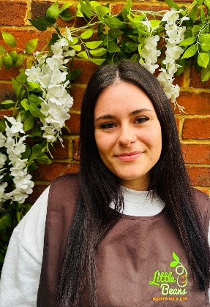“I have been working in childcare for 3 years in which I have developed a huge passion for working with children. I started my childcare journey as an apprentice and worked my way up to becoming a Qualified Level 2 Practitioner. I am very excited to support and nurture your Little Beans’ development whilst in my care.*

*Childcare has always had a special place in my heart from the moment I took on my apprenticeship and I am excited to bring this passion everyday to your Little Beans.”*

**(Level 2 Early Years)**

**Abi – Little Beans Apprentice Teacher, Baby Room**

*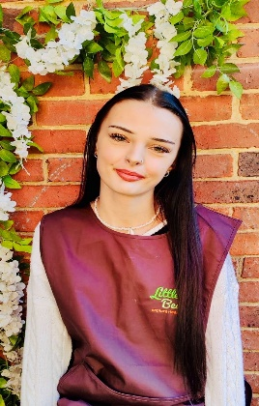“Over the last couple years I have developed my passion for working within the childcare sector. I have a love for helping and supporting children to grow and express themselves and I look forward to bringing this joy when looking after your Little Beans. I’m excited to start my journey as an apprentice to grow and develop my skills further to enable me to provide the best for your Little Beans.”*

**(Working towards Level 2 Early Years)**

**Office Team**

**Gemma - Office Administrator**

*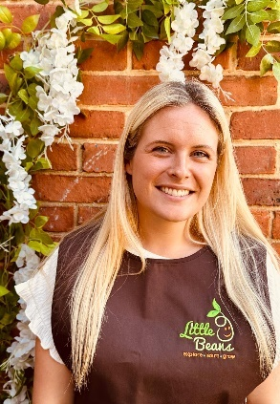“I am thrilled to join Little Beans as the Office Administrator. With over 15 years of experience working with children and babies, I am excited to continue this journey and become a part of the Little Beans family. My background in administration will help me provide welcoming and friendly support to both my colleagues and the parents at our nursery. Outside of work, I stay busy with my two little ones and enjoy family outings. On weekends, I also run a small business as a baby photographer. I look forward to bringing an extra smile to the office, watching your little beans grow, and meeting everyone!”*

**(Level 3 Early Years)**

**Irene - Office Administrator**

*“I have worked in administration roles for many, many years now, and I am a member of the office team at Little Beans. I thoroughly enjoy the balance of working in the office, as well as going and spending time on the floor with all of the Little Beans where I learn all about their weekends and what they get up to outside of nursery. I enjoy spending time with my ever-growing family with 2 Children and 6 Grandchildren. In my spare time I enjoy eating out & visiting new countries on holidays”.*

**In the kitchen**

**Heather – Little Beans Cook**

*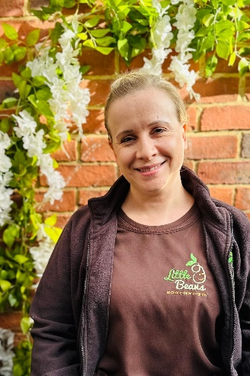****“****I have been working in the catering industry for the past 20 years and I have lots of experience with a variety of foods. I have always loved exploring different foods and being able to cook new and exciting meals.*

*I love bringing my knowledge, experiences and passion for food to your Little Beans! I am excited to support the children's understanding of healthy eating and to provide your Little Beans with a hot, fresh, and healthy cooked meal as I believe every child deserves the best opportunity to grow and develop and part of this comes through the food they consume!”*

**Our team on Maternity Leave!**

**Shawna – Little Beans Teacher, Preschool Room (On maternity leave)**

*“I’ve enjoyed working with children since my work experience when I was 16. Watching the children each grow into their own little personalities makes me happy and being able to make them laugh and smile really brightens my day. I have three nephews and spend a lot of time with them all as a family. I enjoy supporting the children to achieve their next steps and develop as individuals.”*

**(Level 3 Early Years)**

**Tash – Little Beans Teacher & 2 year old’s Room Leader (On Maternity Leave)**

*“From a young age I’ve always wanted to be able to work with children and be apart of their early years’ experience. I love helping children learn and grow in many different ways and being able to support them and have a positive, happy and healthy impact on them through their first few years of development. I enjoy leading a strong team who spend their day working hard with each individual child to achieve their next steps, all whilst making it fun and exciting!”*

**(Level 3 Early Years)**

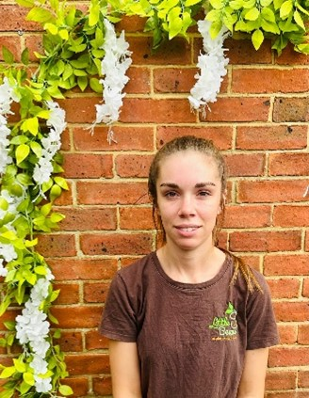

**Laura – Little Beans Cook (on maternity leave)**

**All members of the team at Little Beans are committed to undertaking ongoing development and training. We regularly attend courses to keep improving and hold regular team meetings to share information and provide feedback on any courses that we attend.**

**General Information**

**Settling Visits and Home Visits**

All children will have settling in sessions at no charge. We may decide to offer further settling in sessions if we consider that this would be beneficial to your child considering their individual circumstances and requirements. We also do home visits as we understand some children may settle best when they get to know us in an environment, they feel safe and secure in. Please speak to a member of the team if you would like a home visit.

**Uniform**

We have a **Little Beans** uniform that your child is strongly encouraged to wear during each session they attend. This creates a sense of belonging and helps for school readiness. Details of the uniform are available in a separate leaflet – please ask a member of the team if you have not received this.

If you would like your child to take up a space at **Little Beans** please complete the Registration Form.

**What to bring to Little Beans**

For your child to get the most out of their day please remember to bring a bag containing the following items…

Nappies/underwear

Wipes

Nappy sacks

Slippers

Spare clothing

Welly boots

(We do have messy play)

Jumper/cardigan

Hat

Coat

Sun cream

(Weather is so unpredictable)

Drinking water

(Please no squash etc)

Lunchbox including ice pack.

Communication book (we will provide this to you)

It would be helpful if everything can be labelled so far as possible.

*(Please DO NOT put medicines in your child’s bags they need to be handed straight to your child’s key person and a medication form must be filled in. Your child’s medicine must be clearly named with details of the amounts and times medicine is to be administered.)*

**April 2024 - Fee Schedule**

|  |  |  |
| --- | --- | --- |
| **Session** | **Times** | **Fees** |
| Day space – meals included | 7.30am-5.30pm | £77.00 per day |
| Midi day - meals included (not available if under the age of 2) | 8am-4pm | £66.50 per day |
| Mini day – meals included (not available if under the age of 2) | 9am-3pm | £51.50 per day |
| Early start | 7.30am-8am | £5.20 per session |
| Morning – including meals | 8am-1pm | £43.50 per session |
| Afternoon – including meals | 1pm-5:30pm | £38.00 per session |
| 5 x day spaces – including meals | 7:30am-5:30pm | £350.00 per week |
| Hourly fee | This is the hourly charge for children that are in receipt of funding for any hours that are outside of funded hours | £7.70 per hour |
| Hot Lunch | 11:30am | £3.40 |
| Light Tea | 4pm | £2.75 |
| Hourly consumables fee | For funded children only | £1.50 per funded hour |
| * **Settling in sessions** - no charge (number of settles depend on individual child). * **Food** - Sessions are inclusive of breakfast and afternoon snacks. Hot lunch and light teas are included in session prices if you are not using funding. Families using funding are able to purchase hot lunches and teas at the additional cost listed above. Alternatively, you can provide a packed lunch/tea. Lunchbox suggestions are available upon request. If you require any information about allergens, please speak to a member of the team. * **Minimum Session** – children must attend a minimum of 2 sessions a week. * **Consumable fee** - We will apply a £1.50 consumable fee for every funded hour booked in with us. Please see further information in our T&Cs. * **Notice to change or cancel** - We require one term’s notice for changes to funded hour sessions and one month’s notice for session changes for non-funded hours. This must be put in writing or via an email to [thehub@littlebeansdaycare.com](mailto:thehub@littlebeansdaycare.com) * **Funding eligibility** - You must re-confirm your eligibility every term for the 15, 30 hours funding and tax-free childcare. If not reconfirmed, we are unable to claim funding, so you will be charged for the sessions we are unable to claim funding for. If you require any advice, please speak to the Little Beans Office team. * **Service periods** - We charge for 51 weeks for all year-round children, and 38 weeks for term time only children. * **Admin** - If you require forms to be completed by the Little Beans office team, (e.g., benefit forms), then you must bring the letter in and leave it with us. We will endeavour to complete it within a 14-day period, and we will send it off on your behalf. To enable us to do this, we will require you to bring in the freepost envelope, or a letter with the address and a stamp, or a charge of £2.50 will be charged * **Communication books** - Parents are to replace their child's communication book if they lose it or break it or you will be charged £1.75 for the cost to replace the book with a new one. No costs are involved for a new book for new starters or if the book has been used fully. * **T&Cs** - Please also refer to our Terms and Conditions for further information.   **Funding**  Funding may be available to you - please speak to our office team for further information. | | |

Longfleet church of England V.C. Combined School -before and after school Clubs

|  |  |  |
| --- | --- | --- |
| **Sessions** | **Times** | **Fees** |
| Before school | 8.00am to 8.45am  Includes breakfast snack and walk to school | £5.00 |
| After school | 3.00pm to 5.30pm  Includes school pick up and an afternoon meal | £10.00 |

Little Beans holiday club price list 2024

|  |  |  |
| --- | --- | --- |
| **Session** | **Times** | **Fees** |
| Day space | 7.30am to 5.30pm | £30.00 per day  (hot lunch included) |
| Mini Day | 9:00am to 3:00pm | £25.00 per day |
| * Each holiday club session includes a healthy snack and drink. * If you book a day space your child will receive a mid-morning snack, lunch and an afternoon snack. * All fees are inclusive of food (as stated) and daily trips. * If you require any information about allergens, please speak to a member of the team. | | |

Please refer to our Terms and Conditions for details of payments terms.

We accept: -

* Childcare vouchers
* 9 months, 2, 3 and 4-year-old funding working family’s entitlement
* 2-year-old funding
* Tax Free Childcare – using our Ofsted Registration

BCP Parent Declaration Form for Funding can be found on BCP website:

<https://www.bcpcouncil.gov.uk/documents/children-young-people-and-families/Parent-Declaration-Form.pdf>

For further information please do not hesitate to contact us.

**Weekly activities at Little Beans**

**MONDAY PM – Cooking Class!**

**TUESDAY PM – French Club with Marie!**



**WEDNESDAY AM: Music Lessons with Helen!**



**THURSDAY AM: Dance class with Miss Emily!**



**FRIDAY PM: Cooking Class!**

**Registration Form**

***Please check with us before you take the time to complete this form so that we can confirm we have available space for what you require.***

|  |  |
| --- | --- |
| **Your Little Bean** | |
| Name of child |  |
| Preferred name |  |
| Date of birth |  |
| Male / Female (please circle) | |
| Parent/carer child lives with |  |
| Person/s who have parental responsibility |  |
| Home Address & post code |  |
| Home telephone number |  |
| Ethnic origin/first language |  |
| Other languages |  |
| Religion |  |
| Culture/beliefs |  |
|  |  |
| For Nursery Use Only: |  |
| Date shown around and by whom: |  |
| Date prospectus handed in: |  |
| **Parent/guardian 1** | |
| Name |  |
| Relationship to child |  |
| Home address (if different to child) |  |
| Name and address of employer |  |
| Occupation |  |
| Work contact number |  |
| Mobile number |  |
| Email |  |
| **Parent/guardian 2** | |
| Name |  |
| Relationship to child |  |
| Home address (if different to child) |  |
| Name and address of employer |  |
| Occupation |  |
| Work contact number |  |
| Mobile number |  |
| Email |  |

|  |  |  |  |  |  |
| --- | --- | --- | --- | --- | --- |
| **Person who will normally collect your child (if different)** | | | | | |
| Name | | |  | | |
| relationship to child | | |  | | |
| Contact number | | |  | | |
| **Emergency contact details** | | | | | |
| Password | | |  | | |
| Names of two other persons authorised to be contacted/collect child in an emergency or if parents are unable to be contacted | | | | | |
| Person 1- Name | | |  | | |
| Telephone number | | |  | | |
| Relationship to child | | |  | | |
| Person 2 – Name | | |  | | |
| Telephone number | | |  | | |
| Relationship to child | | |  | | |
| **Health and background information** | | | | | |
| Name of doctor | | |  | | |
| Surgery address | | |  | | |
| Surgery telephone number | | |  | | |
| Health visitors name | | |  | | |
| Health visitor telephone number | | |  | | |
| Special dietary requirements | | |  | | |
| Any allergies? | | |  | | |
| Immunisations (please circle the ones your child has received) | | | | | |
| Whooping Cough | MMR | Polio/Dip/Tet | | Meningitis | Not having any |
| Any other immunisations given to date? | | |  | | |
| Past infectious diseases suffered by your child? | | |  | | |
| Details of any medical or special needs/requirements you would like us to be aware of. | | |  | | |
| Name and contact details of outside agencies involved in supporting your child/family. | | |  | | |
| Does your child attend another childcare facility? If so, please provide name and contact details. | | |  | | |
| Do you have any concerns regarding your child’s development? | | |  | | |
| Name and address of intended infant/primary school? | | |  | | |

|  |  |  |  |  |  |  |
| --- | --- | --- | --- | --- | --- | --- |
|  | **Morning**  **8am-1pm** | **Afternoon**  **1pm-5:30pm** | **Day Space 7:30am-5:30pm** | **Midi Day 8am-4pm** (not available if under the age of 2) | **Mini Day**  **9am-3pm**  (not available if under the age of 2) | **Little Beans**  **Lunch/Dinner**  **(£3.40 per lunch and £2.75 per tea if funded)** |
| **Monday** |  |  |  |  |  |  |
| **Tuesday** |  |  |  |  |  |  |
| **Wednesday** |  |  |  |  |  |  |
| **Thursday** |  |  |  |  |  |  |
| **Friday** |  |  |  |  |  |  |
| **Proposed start date:** | | | | | | |
| **Intended leave date:** | | | | | | |
| **Term time only please select either one All year round** | | | | | | |
| **15 hours funded 30 hours funded** | | | | | | |

**Required Sessions**

**Minimum of 2 sessions weekly must be booked (please tick)**

We require a **registration fee of £50** and a **deposit of £150** when you submit the registration form. Please refer to our terms and conditions set out below.

Please pay by bank transfer and ensure you use your child’s name as the payment reference. Our account details will be detailed on your invoice and can also be requested by contacting our office team.

If a full deposit is paid for your child, then a complimentary Little Beans book bag will be given out.

|  |  |
| --- | --- |
| Print name of parent requesting session(s) |  |
| Signature of parent |  |

**Permissions**

(Please delete each permission as appropriate)

|  |  |  |  |
| --- | --- | --- | --- |
| **Permission** | | | **Your initials** |
| I do/do not give permission for photographs to be taken of my child for displays, journals and record keeping within **Little Beans** | | |  |
| I do/do not give permission for sun cream to be used on my child. | | |  |
| I do/do not give permission for baby wipes to be used on my child. | | |  |
| I do/do not give permission for emergency medical attention to be undertaken on my child. | | |  |
| I do/do not give permission to seek medical help in the case of an emergency. | | |  |
| I do/do not give permission for any emergency medical advice or treatment to be given as considered necessary by medical persons attending. | | |  |
| I do/do not give permission for my child’s food from home to be reheated. | | |  |
| I do/do not give permission for my child to play outside on the play equipment in the garden. | | |  |
| I do/do not give permission to contact your health visitor/GP if we feel it is in the best interest of your child? | | |  |
| I do/do not give permission for us to contact the above settings for the best interest of your child to collect and share information on their learning and development? | | |  |
| I do/do not give permission for my child to go on regular outings. | | |  |
| **Print Name:** | **Signed:** | **Date:** |  |

**Photo Permission**

We would like to take pictures for our website, advertising, and marketing for Little Beans.

We would really like to use pictures of your little beans to portray a true reflection of what we are about. These would be displayed on our website and flyers and used for any marketing/advertisement and social media.

I do/ do not give permission for my child……………………………………….

To have pictures taken whilst at little Beans to be used for our website, marketing, flyers, advertisements, and social media such as our Little Beans Facebook Page.

|  |  |
| --- | --- |
|  |  |
| Child’s name |  |
| Parent’s name |  |
| Parent’s signature |  |
| Date |  |

Any comments………………………………………………………………………………………

………………………………………………………………………………………………………………………………………………………………………………………………………………………………………………………………………………………………………………………………………………………………………………………………………………………………………………………………………………………………

………………………………………………………………………………………………………………………………………………………………………………………………………………………………………………………………………………………………………………………………………………………………………………………………………………………………………………………………………………………………

………………………………………………………………………………………………………………………………………………………………………………………………………………………………………………………………………………………………………………………………………………………………………………………………………………………………………………………………………………………………

**GDPR**

As you may be aware a new data protection standard came into use from May 2018 called the General Data Protection Regulation (GDPR). This means that there are new obligations for companies and how we store your personal data.

Due to this we need to gain your permission clearly about the information that we hold on you and your family.

* The information that you have provided to us previously will be archived accordingly.
* Accident and incident forms will be kept archived until your child reaches the age of 21 years old and any safeguarding paperwork (if applicable) will be kept until your child is 24 years of age in line with current regulations.
* Photographs will be deleted from all computers and memory cards every 6 months as a minimum.
* We will only use your (including your child’s) personal information to provide a childcare service to you. We’d like to keep sending you information about your child/ our nursery (as relevant) by email/ Facebook/ phone etc but we need to make sure that we have your permission to do so. We keep your information, so you can receive important updates about your child/ our nursery. We will keep your information secure and will never share it except if it is required to do so by law.

By ticking this box and signing below you are consenting to us continuing to hold and process your data and send you information.

You can of course ask us not to contact you be email/ phone/ Facebook etc at any time.

Please sign below in agreement with the above statements.

Name__________________ Signed____________ Date_________

Name__________________ Signed____________ Date_________

**H&S: Temperature - Policy & Procedure**

We at **Little Beans** ensure the safety and wellbeing of the children in our care is our upmost priority. We at Little Beans understand that children may fall ill within our care and have a system in place to ensure necessary action can be taken in these circumstances.

If a child has a temperature of 38C or more, then staff will take steps to reduce the child’s temperature such as removing additional clothing e.g jumpers, cardigans, providing fluids to drink and staff will closely monitor the child. A child’s parents/carers will be contacted to collect their child in these circumstances and staff will contact the parent/carer without delay.

**Little Beans** will gain permission from parents to use paracetamol suspension (Calpol 120mg/5ml) as per manufacturer’s instructions at their judgement to reduce high temperatures.

If a child sustains a temperature when they get home, they are unable to return to the setting for at least 24 hours from when the temperature subsided.

If a child’s condition improves without the regular use of medication once home, and they have not sustained a temperature, then parents/carers are advised to contact Little Beans to discuss their child returning to the setting. These circumstances will be reviewed on a case-by-case basis and the decision falls with the nursery manager/nursery deputy.

**Little Beans Medication Permission**

I give permission for Little Beans to administer paracetamol suspension (120mg/5ml) to my child as per the manufacturer's instructions if my child’s temperature reaches 38C or higher.

I understand that in these circumstances, **Little Beans** will contact me prior to administering the medication and that I will arrange collection for my child without delay.

I have read and understood the **Little Beans** temperature policy.

I have been provided with a copy of the manufacturer's instructions for the paracetamol suspension (120mg/5ml).

Name of child:

Name of Parent/Carer:

Signature:

Date:

**Permission form for sharing information**

When a child attends more than one childcare setting, the Early Years Foundation Stage requires each of those settings to share relevant information to support continuity in the child’s learning and development. We also like to work in partnership with other agencies to support the children in our care.

Please complete details of the other persons, organisations or agencies involved with your child: -

|  |  |  |  |
| --- | --- | --- | --- |
|  | **Details** | **Parent’s initials** | **Date** |
| Registered Child-minder |  |  |  |
| Pre-school/Nursery |  |  |  |
| After School/Holiday Club |  |  |  |
| Children’s Centre |  |  |  |
| School |  |  |  |
| Social Care |  |  |  |
| Health visitor  GP |  |  |  |
| Other (please specify) |  |  |  |
| Comments: (any specific comments on information to be shared or information not to be shared) | | | |

Please sign below if you give your permission for information to be shared with the above people, organisations, and agencies. We may still be able to pass on information without your permission if, by not doing so, it would risk harm to the child.

|  |  |
| --- | --- |
| Parent/guardian – Print name |  |
| Signature |  |
| Date |  |
| Parent/guardian – Print name |  |
| Signature |  |
| Date |  |
| Signed on behalf of **Little Beans** in acknowledgement | |
| Print name of signatory |  |
| Date |  |

**Settling in**

We need to know about your little beans’ routine. Please help us build a picture of their week.

|  |  |  |  |  |  |  |  |
| --- | --- | --- | --- | --- | --- | --- | --- |
|  | **Monday** | **Tuesday** | **Wednesday** | **Thursday** | **Friday** | **Saturday** | **Sunday** |
| **Morning** |  |  |  |  |  |  |  |
| **Afternoon** |  |  |  |  |  |  |  |
| **Evening** |  |  |  |  |  |  |  |

**All about me: 3-4 years PRESCHOOL**

|  |  |
| --- | --- |
| My name is |  |
| My preferred name is |  |
| My birthday is |  |
| I live in a (type of home) |  |
| With my |  |
| And my pets |  |
| My religion, culture and beliefs are… |  |
| Special members of my family are |  |
| These are some of my special friends |  |
| Favourite things |  |
| Favourite activities |  |
| Favourite places to visit |  |
| Favourite animals |  |
| Favourite colours |  |
| Favourite sport |  |
| Favourite toys |  |
| Special hobbies |  |
| Other important things about me |  |
| Food (including snacks) |  |
| Drinks |  |
| Allergies/Intolerances |  |
| I love |  |
| I don’t like |  |
| I’m scared of |  |
| My comforter is |  |
| My spoken Language |  |
| I attend Little Beans Term time only | I attend Little Beans all year round |

**All about me: 2’s Room**

|  |  |
| --- | --- |
| My name is |  |
| My preferred name is |  |
| My birthday is |  |
| I live in a (type of home) |  |
| With my |  |
| And my pets |  |
| My religion, culture and beliefs are… |  |
| Special members of my family are |  |
| These are some of my special friends |  |
| Favourite things |  |
| Favourite activities |  |
| Favourite places to visit |  |
| Favourite animals |  |
| Favourite colours |  |
| Favourite sport |  |
| Favourite toys |  |
| Special hobbies |  |
| Other important things about me |  |
| Food (including snacks) |  |
| Drinks |  |
| Allergies/Intolerances |  |
| I love |  |
| I don’t like |  |
| I’m scared of |  |
| My comforter is |  |
| My spoken Language |  |
| I attend Little Beans Term time only | I attend Little Beans all year round |

**All about me: 0-2 years BABIES**

|  |  |
| --- | --- |
| My name is |  |
| My preferred name is |  |
| My birthday is |  |
| I live in a (type of home) |  |
| With my |  |
| And my pets |  |
| My religion, culture and beliefs are… |  |
| Special members of my family are |  |
| Special friends |  |
| Favourite things |  |
| Favourite places to visit with my family |  |
| People who will be dropping me off & picking me up will be… |  |
| I attend nursery (sessions) |  |
| Foods I like |  |
| Foods I don’t like |  |
| When I have milk |  |
| I like… |  |
| I don’t like… |  |
| My sleep times/duration of naps |  |
| My comforter is… |  |
| My spoken language at home… |  |
| Any extra information (e.g. allergies, specific medical history to be aware of) |  |

**Distinctive Marks**

**Does your child have any distinctive marks on their body? (such as a birth mark or other permanent mark). If so, please could you indicate on the maps below.**



**Parent in partnership agreement**

At **Little Beans** we know how important it is to have the best partnership possible between us and you as parents and families. This ensures that we can all work together for the best interests of your child, enabling them to feel confident and able to settle in too **Little Beans** as quickly as possible; ready to learn, develop and achieve!

We use the Early Years Foundation Stage to observe record and plan for your child and their next steps, so they can reach their full potential and always feel challenged. You as families are the key as you know your children best, so we would like to enter into an agreement to work in partnership together as follows: -

At **Little Beans** we agree to: -

* Ensure that the transition period for your child to start is a smooth and positive experience. We will do a home visit if you wish to meet you and your family, to go through the prospectus together and answer any questions you may have. This also enables us to meet your child in their own environment to feel more safe and secure and build positive relationships.
* Find out as much information as possible about your child so they can settle quickly and confidently. The information we have will also be a starting point to commence the learning journals along with observations and recording to enable planning and next steps to be put in place.
* Allow settling in sessions - as many as needed depending on your individual child and until everyone agrees that they feel secure enough to be left.
* Maintain a daily register where everyone will be signed in and out. We will not allow anyone other than you or your authorised persons to collect your child. We will keep a contact register in case you are unavailable.
* Administer medicines as prescribed by the doctor (a medical form will need to be completed).
* Ensure that we will do our best to comfort and look after your child if they become ill throughout the day and we will inform you as soon as possible.
* Advise staff at **Little Beans** of any outbreaks of infections, diseases, or cases of head lice.
* Inform you of any incidents or accidents that may have occurred at **Little Beans** and or affected your child during the day.
* Hold regular parent’s evenings to share information on your child and keep you update on your child’s progress and development.
* Do regular questionnaires to gain constructive feedback and any suggestions to monitor and help improve the service we provide.
* Implement a policy of equal opportunities (enshrined in law). We help children to learn about other cultures and aim to develop their respect and tolerance for race and religion. We ensure that boys and girls are treated equally and given equal access to all activities and appropriate responsibilities. We keep a number of written policies at **Little Beans** including equal opportunities behaviour management and child records.
* Encourage your child to experiment with a variety of materials and be creative; doing so they may get messy even though we encourage them to wear aprons.
* Provide organised visits into the local area and we will always advise you in advance when these are planned.
* Always comply with staff ratio’s set out in the statutory framework for the Early Years Foundation Stage.

**Parents/carers agree to:**

* Choose whether you would like a home visit.
* Attend **Little Beans** with your child during the settling in time until your child is ready, confident, and happy to be left.
* Inform us of any absences.
* Inform us if you cannot collect your child and who will.
* Share your child’s interest by talking with them and to their key person about what they have been doing.
* Give us the names and telephones numbers of people we can contact in case of sickness or emergency and inform us of any changes.
* Keep a sick child at home and collect one if they become ill whilst at the setting as soon as possible.
* Inform us if your child has contracted an infectious disease or has/had head lice.
* Inform us of any significant changes which may affect your child’s behaviour.
* Inform and tell us about your own observations and provide comments which can be added to your child’s records.
* Accept and adhere to the policy of equal opportunities within **Little Beans**.
* Read and familiarise yourselves with the policies and procedures at **Little Beans** and inform staff if you do not understand anything in the content.
* Provide sensible and appropriate clothing.
* Give consent to visits into the local area for your child’s development and enjoyment.
* Attend parent’s evenings to discuss and share your child’s development.
* Pay fees promptly.
* Unfortunately, staff members cannot accept parents and carers on Facebook, even after staff leave employment with **Little Bean**

**Policies & Procedures**

|  |
| --- |
| **Safeguarding** |
| Safeguarding  Whistleblowing  Intimate Care  Mobile Phones, Cameras, Video Recorders, I-Watches & the Internet Prevent Duty Lock Down & Movement Around Building Lone Working |
| **Record Keeping & Complaints Handling** |
| Record Keeping & Complaints Handling Confidentiality, Data Protection & Record Keeping GDPR |
| **Health & Safety** |
| Lost, Missing or Unaccompanied Child Evacuation Fire Drill Outings Food & Drink Illness & Infectious Diseases Incident & Emergency Medicines  Temperature Risk Assessments Prevention of Cross Infection & Waste Disposal Un-Collected Child |
| **Staffing** |
| Recruitment of & Checks on Staff  Staff Supervision, Training & Development Staff Ratios & Key Person  Staff & Employment |
| **Working with Parents - Settling In & Parent Partnership** |
| **Special Educational Needs** |
| **Behaviour & Anti-Bullying** |
| **Inclusion & Equal Opportunities** |
| **Home Visits** |
| Home Visits for New Starters |
| Home Visits for Family Support |
| **Student Placements & Volunteers** |
| **Tapestry** |

These policies and procedures are available on our website. However, if you would like a printed copy, we would be more than happy to arrange this for you. If you would like to discuss any of the policies and procedures, please do not hesitate to contact us.

**Terms and Conditions**

1. **Fees** - You are required to pay the fees in accordance with the rates set out in the current fee schedule. Fees are charged 51 weeks (AYR) or 38 weeks (TTO), whether your child attends or not. We will review fee rates on an annual basis and will notify you in writing at least 1 month before any fee changes will apply. Fees are payable for any holiday time or other absences, including illness, that your child takes away from Little Beans.
2. **Registration Fee and Deposit -** The registration fee paid at the time of registering your child’s required space at Little Beans is ***non-refundable***. The deposit fee paid at the time of registering/starting at Little Beans is ***non-refundable*** if your child does not take up the space at Little Beans. The deposit will form part of the general funds of Little Beans. The deposit is ***only refundable*** if your child leaves on or after the leave date you specified when you registered at Little Beans (which is subject to correct notice period being given – see term 9 below). In those circumstances, the deposit will be refunded to you by bank transfer once all outstanding sums/balances owing to Little Beans have been paid in full.
3. **Payment** - Fees must be paid in advance *before* the 1st day of each calendar month. Payments must be made by bank account transfer/standing order/ direct debit and your child’s full name needs to be put as the reference.
4. **Vouchers** - We can accept childcare vouchers however they need to be submitted in advance so that payment is made *before* the 1st of each month.
5. **Holidays** - Fees still apply and will be charged for bank holidays and public holidays when Little Beans is closed if your child would usually attend on that day of the week.
6. **Closure** - We will be closed for 1 week at Christmas and will notify you in advance of our closure dates. These are also available on our Website - <https://littlebeansdaycare.com/whats-on/>
7. **Late collection -** If you are late in collecting your child at the end of booked sessions, we reserve the right to charge additional fees on an hourly basis.
8. **Late payments -** If payments are made more than 3 days late you will incur a late payment fee of £25.00. If fees are unpaid this may lead to: -
   1. Withdrawal of further childcare until payment is made; and
   2. Termination of the agreement and we will take necessary action to recover all fees due and costs incurred in such action including administration and legal.

In addition, where payments are more than 30 days late, we reserve the right to charge penalty interest at the rate of 8% above the Bank of England base rate – to be calculated from the due date of payment to the date of actual payment.

1. **Changes/leaving date -** For funded sessions you must give a full term’s notice and for non-funded sessions you must give a full calendar months’ notice **-** in writing if you wish to change, cancel, or end our agreement including notifying us of your child’s leaving date (even if you specified your leave date on your initial registration form).
2. **Absences** - You must inform us as soon as possible if your child is absent for any reason.
3. **Illness** - If your child is ill during the day, we will contact you to collect your child in accordance with our illness policy. You must plan for your child to be collected within the hour. We must be notified immediately in writing or by telephone in an emergency if your child suffers from any infectious or contagious diseases.
4. **Medications** - We will require written consent to administer any prescribed medicines and your child’s name must be clearly visible on the medicine bottle/packet. We will make all reasonable medical decisions and seek medical help if we are unable to contact any of the individuals listed on your registration form. In line with our medicines policy, we reserve the right to refuse to administer certain medication. The safety and wellbeing of a child is our first concern, and we will take the appropriate action if we feel that a child is at risk.
5. **Funding** - If you have not provided evidence that you have reconfirmed for the 30 hours eligibility then they will be required to pay the monies outstanding.
6. **Letters -** If you require forms to be completed by the Little Beans office team, (e.g., benefit forms), then you must bring the letter in and leave it with us. We will complete it within a 14-day period, and we will send it off. To enable us to do this, we will require you to bring in the freepost envelope, or a letter with the address and a stamp, or a charge of £2.50 will be charged.
7. **Start date –** We require you to confirm your start date when completing the registration form, once your deposit and registration fee has been paid, we will then book your required sessions in from the date requested on your registration form. You will not be able to change your start date, however, can give one full calendar month’s written notice to change your sessions booked in to the minimum 2 sessions per week required.
8. **Consumables fee -** We will apply a fee of £1.50 for every funded hour that is booked in for any children that are in receipt of funding. This charge is to cover the costs of many things such as snacks, resources, Additional classes (cooking lessons, Yoga, Dance class and French lessons), Outings and all the wonderful additional experiences the children will enjoy and benefit from whilst at Little Beans.
9. **Holidays when funded** - If your child's sessions are funded, we are limited to the amount of weeks we are able to claim funding for your child if absent from little Beans due to being on holiday during a funded week. For term time only children, we are able to claim a maximum of two weeks funding per funded year for absence due to holidays, for All year-round children, we are able to claim a maximum of three weeks funding per funded year for absence due to holidays. You will be liable to pay full fees for any sessions during the funded year once the holiday allowance has been claimed and the limit of either two or three weeks has been used.
10. **Extended absence when funded** - In the instance that your child is absent for longer than the allowed holiday timeframes set, due to visiting a home country, we will be able to claim funding for a maximum of 4 consecutive calendar weeks per funded year. You must inform us of the intended absence in writing in advance, should the extended visit result in your child being absent from their funded sessions for longer than 4 consecutive weeks, full fees will be applied for any sessions after the 4-week period.

**Parent Acceptance of Terms**

I/We have read, accept, and agree to adhere to: -

* **Little Beans’** Terms and Conditions
* Fee information
* Parent Partnership Agreement
* Completed Registration Form
* Completed Permission Form
* Completed Permission Form for sharing information.
* Policies and procedures of **Little Beans**

|  |  |
| --- | --- |
| Parent/guardian – Print name |  |
| Signature |  |
| Date |  |

|  |  |
| --- | --- |
| Parent/guardian – Print name |  |
| Signature |  |
| Date |  |

|  |  |
| --- | --- |
| Signed on behalf of **Little Beans** in acknowledgement | |
| Print name of signatory |  |
| Date |  |



**Dear Parents and carers,**

Here at **Little Beans** we are using an online system called Tapestry to record and store all observations and assessments relating to your child. Tapestry is a safe and secure system and one that enables you as parents and carers to access your child’s learning journey at any time. You can share it with your child, family and friends at home and also post any comments and photographs of your own, helping to create a fully holistic view of your child so we at **Little Beans** can maintain a high standard of parent partnership.

**Safety and security**

Staff use tablets to take the photographs for observations which are uploaded to Tapestry instantly. Each staff member has a secure login which is password protected. The tablets are kept in a secure cupboard at **Little Beans** and are never taken home by staff. Staff will be allocated time at work to update journals and plan for their key children’s next steps.

If any member of staff suspects that their login details have been compromised in any way, they will inform the Manager, Emma Miller or follow the safeguarding contingency plan in her absence and new login details will be created. The Tapestry Learning Journey system is hosted on secure dedicated servers based in the UK. All data held on Tapestry account is owned by **Little Beans**; we are registered controllers of data with the Information Commissioner’s Office and are bound by the Data Protection Act.

**Parental Access**

As parents you are able to log in to the Tapestry system, but you will only be able to access your own child’s Learning Journey. You may input new observations and photos and add comments to existing observations. However, you will not have the necessary permission to edit existing content that has been inputted by your child’s keyworkers. At the end of this letter is a permission form. We at **Little Beans** require you to sign a consent form giving **Little Beans** permission for your child’s image to appear in other children’s Learning Journeys.

No photos or observations must go on to any social network site / website if it includes a child that is not yours. Any person seen to be not following the policy may lose their place at Little Beans as this is a security and safeguarding breach of our policy.

**Parents without internet**

If you do not have access to the internet, **Little Beans** will print all the information from Tapestry and collate it into a paper Learning Journey. This will be stored in **Little Beans** for you to view at all times and will be available to take home. Please inform the office if you require us to do this.

**Little Beans** Garland



Child Name……………………………………………………

Child DOB:…………………………………………………

I (do / do not) give permission for **Little Beans** to take photos of my child for the purpose of the Tapestry online Learning Journey.

I (will / will not) input observations, photos and add comments to observations completed by my child’s keyworker.

I (do / do not) give **Little Beans** permission for my child’s image to appear in other children’s Learning Journeys.

I will not upload on to any social media site or website if it includes a photo of another child. I understand if I do this it may result in my child’s place being cancelled due to breaching the policy as this is a security and safeguarding breach.

I understand it is my responsibility to download my child/ren’s learning journey myself when my child leaves Little Beans. I will inform the office team if I need support or are unable to download it myself.

Parent Name…………………………………………………

Parent Signature………………………………………………